Object-Oriented Design

Sample Solution

Software Architecture Workshop
(Java AWT)



©2010 NUS. The contents contained in this document may not be reproduced in any form or by any means, without the written permission of ISS, NUS, other than for the purpose for which it has been supplied.

Sample Solution to Software Architecture Workshop

Correct vs. Right Solution
There is no one correct solution for the transition strategies. The challenge is to devise the right strategies that is suitable for the project and the team. The right strategies tend to be:
- the work of the expert designers in the specific technologies.
- reflecting the design consensus of the project team.
- sufficiently detailed (i.e. unambiguous) for the designers to proceed with their work on different use cases. But how do we ensure this?
- not overly burdened with implementation details that are usually left to the discretion of the programmers.
- sufficiently scoped (i.e. complete) for the designers to deal with the typical design concerns they might face.
- equipped with examples to illustrate difficult design guidelines.

Transition Strategy for AWT Library
The GUI of the MaxVision case study will be implemented using the AWT library. While it is possible to leave some of the details in this strategy to the programmer, it is assumed in this exercise that we wish to model the design till the “screen” of AWT, e.g. frame, panel and dialog. We choose not to model the more granular components of AWT, e.g. button, text field, etc. – one exception is those components that allow the user to trigger the system.

Impacted Analysis Objects
All the screen boundary objects are impacted. They are to be adapted to use the AWT objects to display information and accept user actions.

All the control objects that interact with the with the screen boundary objects are impacted. They are to be adapted to make request to the adapted screen boundary objects as well as to handle user actions effected through AWT objects.

Impacted Use Cases
All the use cases that perform user interaction are impacted. For examples, Create Member and View Member Details use cases.

Transition of Static Structure
The following class diagram illustrates the static structure of the design.
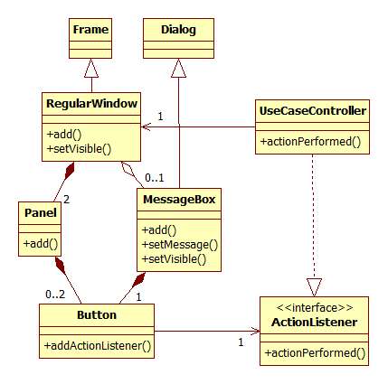

The screen boundary objects will be classified into two types: regular window and message box.

A regular window would be a AWT Frame object in which other AWT Panel objects can be added. AWT Component (e.g. Button) objects can then be added into the earlier AWT Panel objects. In the MaxVision case study, Main_Menu and Create_Member_Form are examples of regular windows.

A message box is used by a regular window to display messages that require user attention. So a message box exists in the context of a regular window. Since at most one message is shown at a time, there should only be at most one message box per regular window. A message box would be a AWT Dialog object which three AWT Component objects: They are one AWT TextArea object (for the message text) and one AWT Button objects (for the OK button). In the MaxVision case study, Create_Member_Form will use a message box to display message to the user.

For simplicity, user actions on the screen boundary objects will be effected by selecting AWT Button objects in both the regular window and message box. This means the use case controller will only need to implement the AWT ActionListener interface for listening to button selection events. The use case controller will also instructs the regular window to perform specific user interactions. In the MaxVision case study, Member_Services_Controller instructs Create_Member_Form to display message to the user.

Transition of Dynamic Interactions
The following sequence diagram illustrates the typical dynamic interactions of the design for the instantiation of a regular window and the handling of user selection on a button.

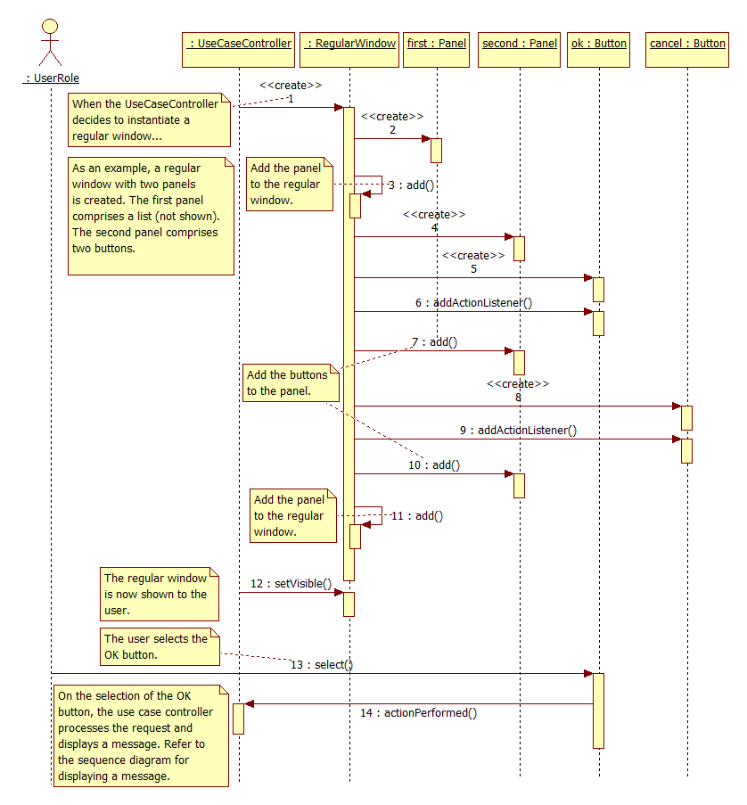

The following sequence diagram illustrates the typical dynamic interactions of the design for the instantiation of a message box, the displaying of a message, and the handling of user selection on a button.

